Mushroom classification

Start page:

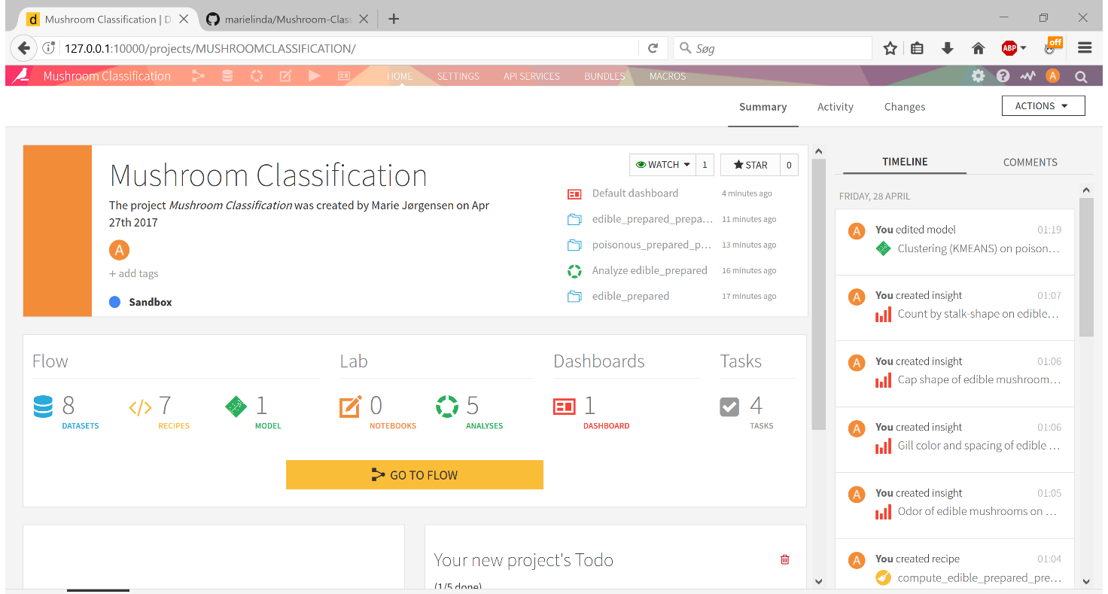

Flow chart:

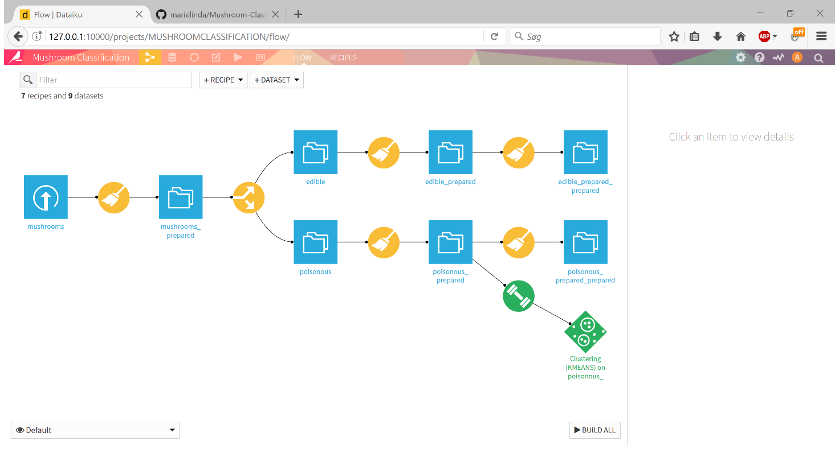

Dashboard slide 1 (for ‘poisonous’ dataset):

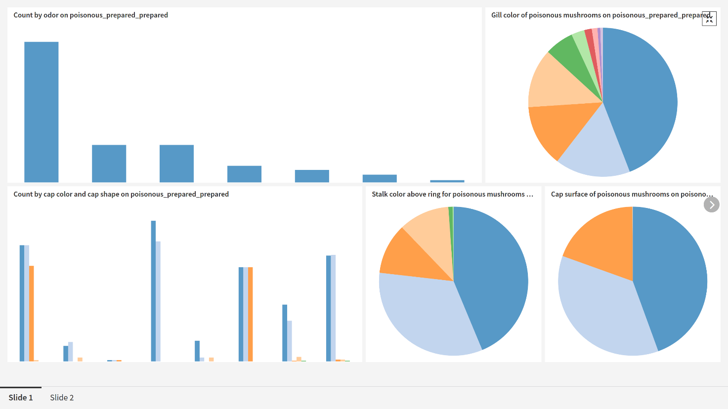

Dashboard slide 2 (for the ‘edible’ dataset):

